Lesson 4 Project

Kristin D’Ambrisi

IT245-01 Website Development
Professor Martignon
October 30, 2005

COMPLETE THE PROJECT: SECTION 2 CASE STUDY
Complete all of the Section 2 Case Study on page 4.30 of the textbook.
The Case Study is an ongoing development process in Web design using the concepts, techniques and Web Design Tips presented in each section. In Section 1, you selected the type of Web site (personal, organization/topical, or commercial), a topic of interest and title, goals, elements, and design tools.
With these components in place and your understanding of the connection between a detailed design plan and a successful Web site, complete the assignment to implement the six steps for developing the solid design plan presented in Chapters 3 and 4 for your Web site. The time you spend developing your plan is a wise investment, which will yield high dividends.
1. Open the one-page document in which you created the outline using a text editor or your word processing program. Name the document Design Plan.
✓
2. Use the six steps presented in Section 2 to define the purpose, identify the audience, plan the content, plan the structure, plan the Web pages, and plan the navigation to develop the design plan for your Web site.
✓
3. Include all of the components presented in the Design Plan Checklist to make your design plan detailed and specific.
✓
4. Hand in the design plan to your instructor.
✓Taken from:

IT245-02

Lesson 2 Project
October 16, 2005

Design Plan

1. Identify which type of Web site you will design: (a) personal, (b) organization/topical, (c) commercial; the topic, and the title you will give your Web site.
I will be designing a Web site for my father’s business, Gentlemen’s Quarters, a barbershop. It is located in Long Branch, NJ. He celebrated 40 years of business this past year. He has an extensive group of regular customers and is always acquiring new customers. The Web site will be titled “Gentlemen’s Quarters”.

2. List three or more general goals for you Web site. (You will fine-tune these goals into a specific purpose in the next section.)
Goals of this Web site are going to be to advertise to new customers, allow current customers to contact the barber for an appointment, allow customers to view an online catalog of products sold at the shop, as well as display other pertinent information about the business.

3. List any elements other than text – for example, photos, animations, or music – that you could include on your Web site to support your general goals.
Elements other than text that will be used on the Web site are photos and animations to make the site more appealing and interesting.

4. Identify the design tools you think you will need, including software, hardware, and any specialty equipment.
Some design tools that will be needed to create the Web pages are either a text editor or Web authoring program such as Dreamweaver. Fireworks can be used to design graphics. A Wacom pen tablet will also be used to help with creating graphics.

5. Identify any other issues you will consider in the design of your Web site.
Some issues that will be considered in the design of the Web site are accessibility and browser compatibility. Testing and maintenance are also important things to consider.

Lesson 4 Project
October 30, 2005

Design Plan

Define the Purpose
The purpose of this Web site is to promote the business and advertise to new customers, give current customers the ability to schedule appointments, find products offered at the barbershop, find information about the barber, and find other information regarding the business such as emergency closings and holiday closings.

Identify the Audience
The audience of this Web site is the current customers and prospective customers. The current customer base is made up mostly of Caucasian males, with varying incomes, ranging from young children to men in their 90s. They mostly live in the Monmouth and Ocean County areas of New Jersey, with a few residing in New York City. The prospective customers will most likely belong to those categories.

Plan the Content
The pages will be professional and not flashy. The content of the pages will be arranged in short, easily read paragraphs. A clear font and neutral colors will be used. The content will be written in a friendly tone and updated regularly and as often as needed.

Plan the Structure
This Web site will be small, containing 5 to 10 pages. A random structure will be used, as visitors will be able to visit any or all pages, in any order. A general diagram can be found on page 6 of this document.

Plan the Web Pages
Pages the site will contain:

Home Page-This page will have a photograph of the barbershop as the main graphic. Typical information such as location, hours, and contact information will be on this page. A navigation structure will be located on each page in a consistent location. A logo will also be on each page, linking to the home page.

Biography-This page will have a photograph of the barber and professional as well as personal information about him so customers, old and new, will know more about their barber. Links to topical Web sites of interest to the barber may be found here. Any newspaper articles regarding the business will be available by a link from this page.

Newspaper Articles-This page will contain newspaper articles featuring the barbershop.

Catalog-This page will have images and prices of products offered at the barbershop.

Calendar-This page will have calendar images containing information such as days the barbershop is closed regularly and for holidays.

Appointments-This page will allow visitors to fill out a form to request an appointment. This form will be emailed to the barber for follow-up. Eventually, this page will be linked to a database that contains currently scheduled appointments so visitors will have the ability to schedule an appointment in an available slot without having to wait for confirmation from the barber. This will be useful for customers who wish to schedule multiple appointments in advance.

Emergency Information-This page will contain information regarding emergency closings. Visitors could check this prior to an appointment.

Coupon-This page will contain a printable coupon for new customers to use on their first visit. Any other coupons that will be made available to customers will be posted here in a printable format. The will vary, so customers can check back regularly.

Plan the Navigation
Navigational elements such textual links, graphical links, and buttons will be used. This Web site will be both user-based and user-controlled by providing different ways to navigate the Web site and allowing them to choose their course through the pages.

Random Structure

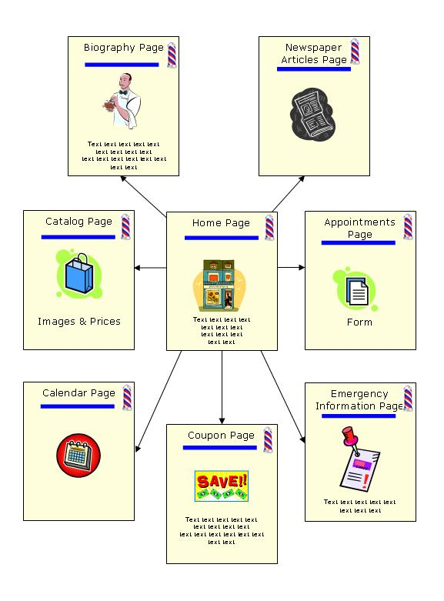

References

Shelly G., Cashman T., and Kosteba L. (2002) Web Design Thomson Course Technology.

