Lesson 5 Project

Kristin D’Ambrisi

IT245-01 Website Development
Professor Martignon
November 13, 2005

COMPLETE THE PROJECT: "HANDS ON" EXERCISE 1
Complete "Hands On" Exercise 1 on page 5.27 of the textbook. Do the exercise in Microsoft Word.

1. Start your browser and locate a Web site that has applied good graphic typography, and then locate a Web site that has not applied good graphic typography.

- Identify the basic graphic typography principles that have and have not been applied to each Web site.

A Web site that applies good graphic typography is United Healthcare’s consumer Web site at https://myuhc.com/. The text is clear and easy to read. The colors flow and provide good contrast with the background. Sans serif text was used, making it clear and easy to read. Links are clear to see and buttons are consistent throughout the site. Line length is good because it allows the eye to scan the text.
A Web site that does not apply good graphic typography is San Francisco’s Superior Court Electronic Information Center Web site at http://www.sftc.org/. This site is not as professional as it should be. There is no consistency throughout the page. It is difficult to read the scrolling text and since it does not continuously scroll, the visitor cannot read the beginning of the message if they miss it. Too many colors are also used throughout the Home page, there is poor contrast between the background and text, and all of the buttons don’t match. For some reason, the text in the table with the red border is difficult for me to read. Line length of the text on this page seems to be too long. Being a government related Web site, this site should have more neutral colors, have a more consistent look to it, and be more organized.

- Explain what you think might be the impression on a visitor viewing each Web site for the first time.

The https://myuhc.com/ site is very professional looking. It is clean and organized. A visitor to this site may think this is a credible and good quality health care provider. They may feel safe using this company. This proves that good use of typography is important on the Internet as well as on paper.
I was not impressed at all by the http://www.sftc.org/ site because of its inconsistent, unprofessional look. A visitor to this site may feel apprehensive about the services they may receive from this company due to the lack of professionalism throughout the site. If they had applied better graphic typography techniques, this site may be more effective.

https://myuhc.com/
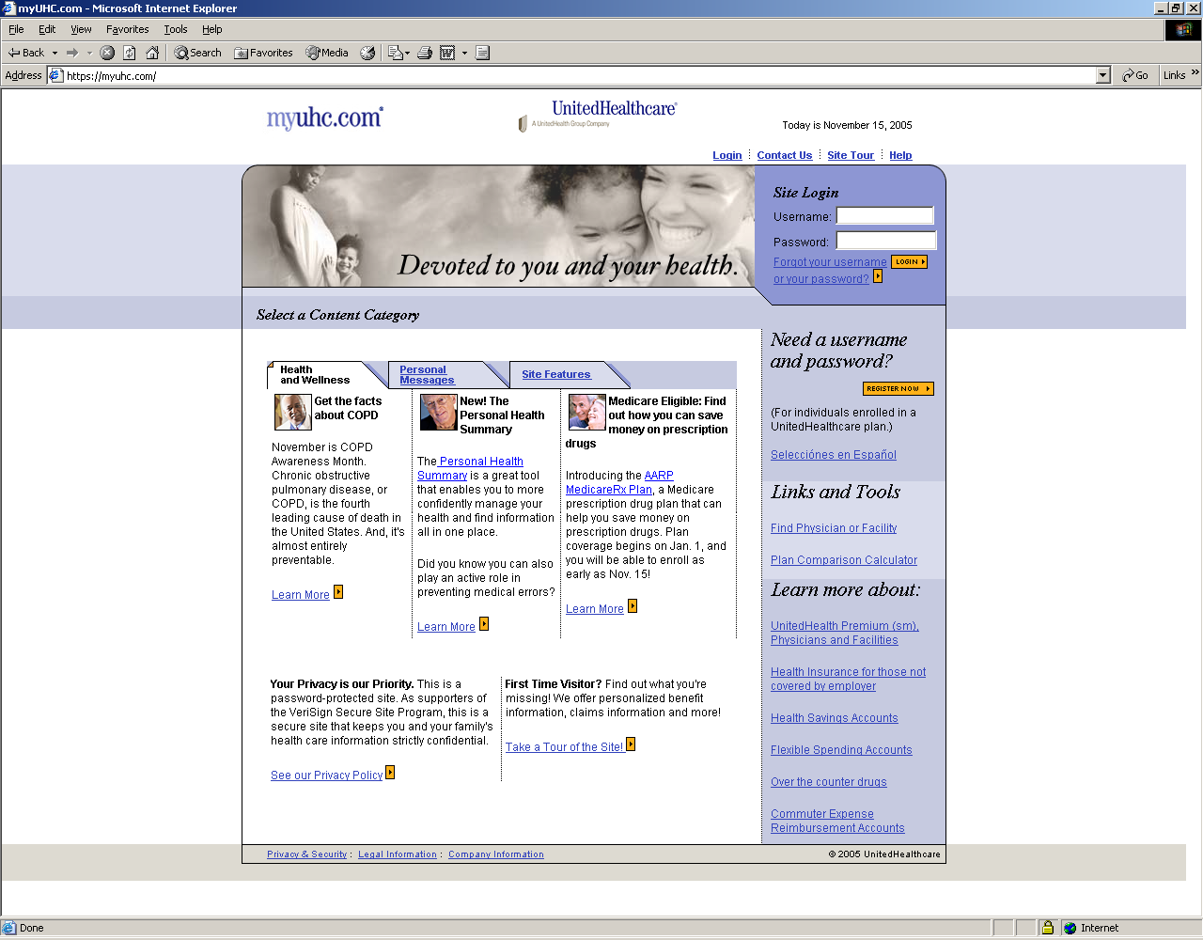

http://www.sftc.org/

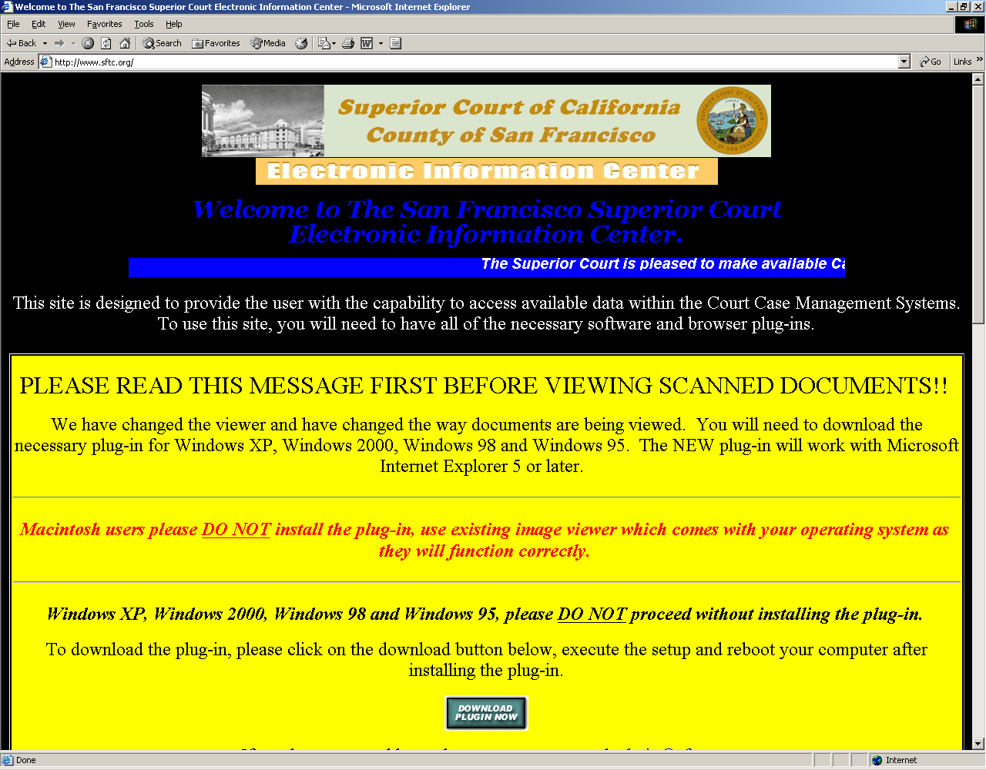

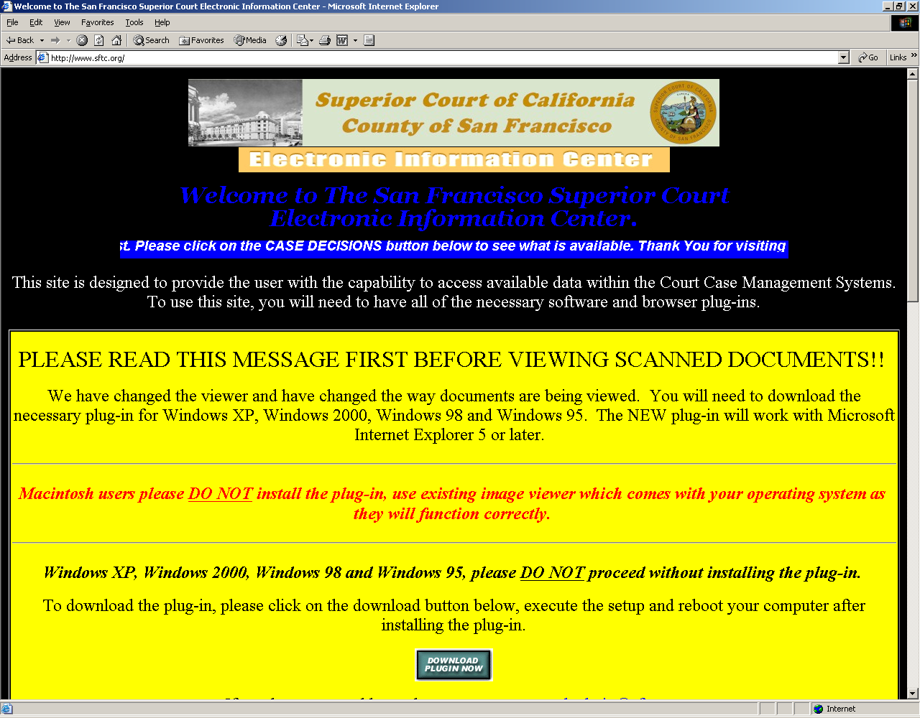
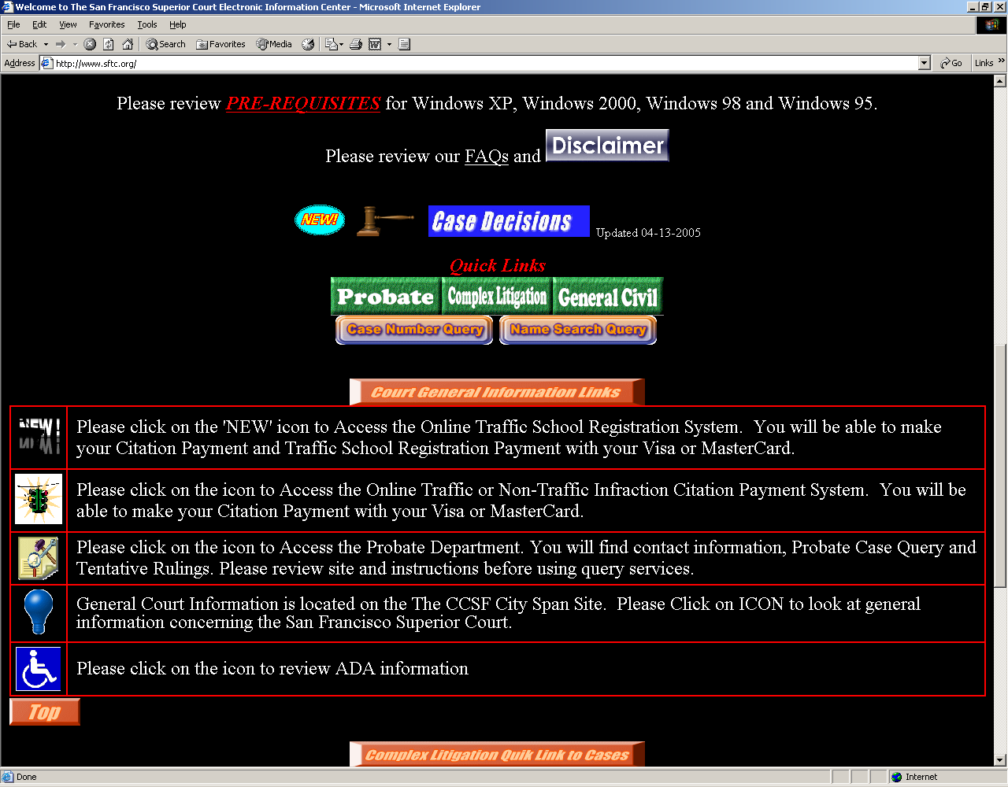

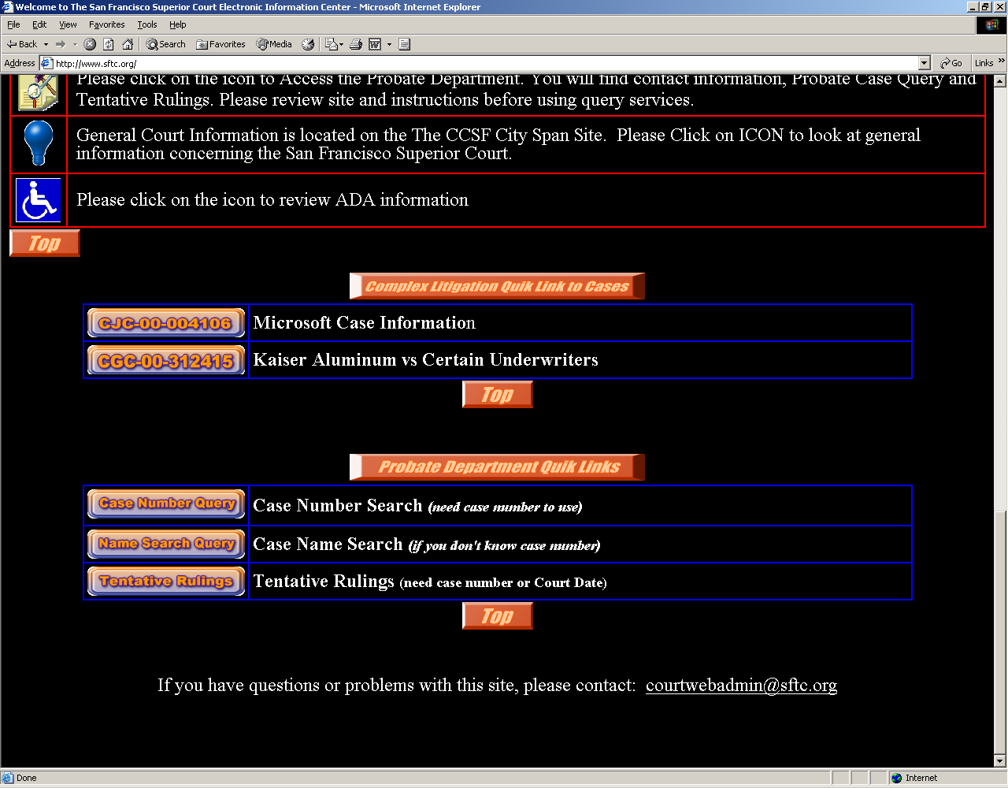
References

San Francisco’s Superior Court Electronic Information Center Web site at http://www.sftc.org/, visited November 13, 2005.

Shelly G., Cashman T., and Kosteba L. (2002) Web Design Thomson Course Technology.

United Healthcare’s consumer Web site at https://myuhc.com/, visited November 14, 2005.

